Practical No. 4
- Aim: Multiclass Classification
- Description: This code trains a neural network to classify Iris flowers into three species.
It loads the dataset, splits it into training and test sets, and scales the features.
A Sequential model with two hidden layers (ReLU) and a softmax output layer is built.
The model is compiled with Adam optimizer and categorical cross-entropy, then trained for 50 epochs.
Finally, it evaluates test accuracy and predicts class labels and probabilities for new samples.
Code:
# If TensorFlow is not installed, uncomment the next line
# !pip install tensorflow scikit-learnimport numpy as np
import tensorflow as tf
from tensorflow.keras.models import Sequential
from tensorflow.keras.layers import Dense
from tensorflow.keras.utils import to_categorical
from sklearn.datasets import load_iris
from sklearn.model_selection import train_test_split
from sklearn.preprocessing import StandardScaler
# Load dataset
data = load_iris()
X = data.data # Features
y = data.target # Class labels (0,1,2)
# Train-test split
X_train, X_test, y_train, y_test = train_test_split(
X, y, test_size=0.2, random_state=42
)

# Feature scaling
scaler = StandardScaler()
X_train = scaler.fit_transform(X_train)
X_test = scaler.transform(X_test)

# One-hot encoding labels
y_train = to_categorical(y_train, num_classes=3)
y_test = to_categorical(y_test, num_classes=3)

model = Sequential([
Dense(64, activation='relu', input_shape=(X_train.shape[1],)),
Dense(32, activation='relu'),
Dense(3, activation='softmax')
])
model.compile(
optimizer='adam',
loss='categorical_crossentropy',
metrics=['accuracy']
)

model.summary()

history = model.fit(
X_train,
y_train,
epochs=50,
batch_size=16,
validation_split=0.1,
verbose=1
)
test_loss, test_accuracy = model.evaluate(X_test, y_test, verbose=0)
print(f"Test Accuracy: {test_accuracy:.4f}")

# Predict probabilities
y_pred_prob = model.predict(X_test)

# Convert probabilities to class labels
y_pred_class = np.argmax(y_pred_prob, axis=1)

print("Predicted classes:", y_pred_class)
print("True classes:", np.argmax(y_test, axis=1))

sample = X_test[0].reshape(1, -1)
prediction = model.predict(sample)
predicted_class = np.argmax(prediction)

print("Predicted class:", predicted_class)
print("Class probabilities:", prediction)
Output:

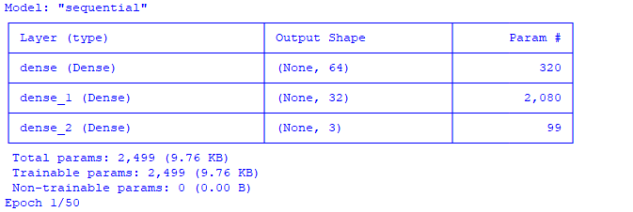
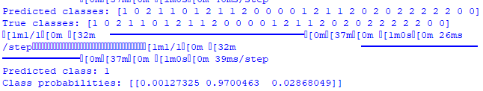

Learnings:
- Data preprocessing matters – scaling features and one-hot encoding labels improve neural network performance.
- Neural network architecture – using hidden layers with ReLU and a softmax output allows effective multiclass classification.
- Model compilation choices – selecting the right optimizer (Adam) and loss function (categorical cross-entropy) is crucial for training.
- Evaluation and prediction – splitting data, checking test accuracy, and converting probabilities to class labels shows how well the model generalizes.
- Hands-on understanding – practicing with a small dataset like Iris helps understand neural networks, training, and prediction workflows.
If you want, I can also summarize this into 3 super concise points for quick notes.

